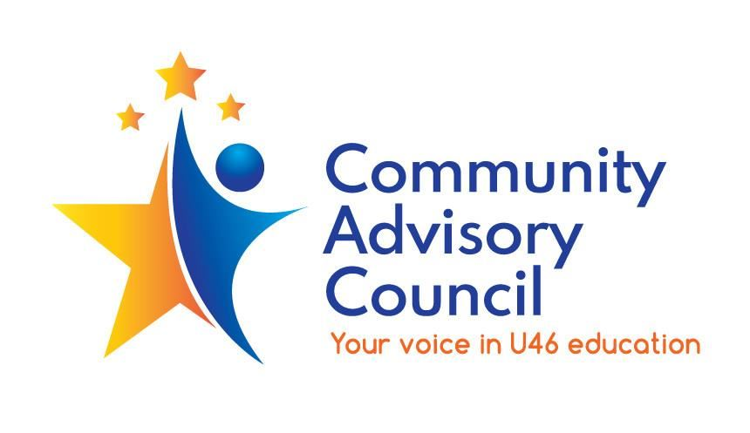

**Community Advisory Council General Committee Meeting Minutes**

October 5, 2023

1. **Call to order:** Meeting called to order at 7PM by Matt Hovey. Meeting was held in person at the Elgin High School library. Members of CAC Executive committee, representatives of School District U-46 and guests were in attendance. The business portion of the meeting was recorded for future viewing.
2. **Approve prior meeting minutes:** Minutes for May 4, 2023 and September 7, 2023 General Committee meetings with a motion to approve by Ginger Kurtz and a second by Heather Matthews. Both sets of meeting minutes were approved by unanimous vote.
3. **Board of Education Update:** Provided by Dawn Marting. This week two thousand U-46 eighth graders are scheduled to attend the Explore event to be held at the NOW Arena in Hoffman Estates. Applications for the five U-46 Magnet Academies opened on October 4th. Open House events are schedule for the next two weeks at each Academy. Information sessions about U-46 Gifted Program screenings for 3rd and 6th graders and Dual Credit for high school Junior and Seniors will be held in the upcoming weeks. Next Board of Education meeting is scheduled for October 23, 2023.
4. **Public Comments:** Katrina Neal a parent with students at Hilltop Elementary School and Ellis Middle school spoke to thank the Board of Education for having the bike rack at Ellis Middle School replaced.
5. **Business Agenda – Committee Updates**
   1. Instructional Initiatives update provided by Heather Matthews. The committee will do a deep dive into District initiatives. The focus of the next meeting will be on Magnet Academies and Pathways. What are the impacts the changes to the Academy application process and Pathways. The meeting will be on October 25th at 7PM via Zoom. The November meeting will on U-46 Rising. There is no meeting scheduled for December. The January meeting will focus on the impact of Gifted Services for High School students.
   2. Specialized Student Services update provided by Ginger Kurtz. All their meetings are held via Zoom. They are both parents of students who utilize the Districts Specialized Student Services - students who have 504 or IEPs. Their next meeting will be a presentation by Joey Williams on Executive Functioning – Preparing for Life. The meeting will be on October 24th at 7pm via Zoom.
6. **Other** **Business**: The second Unite U-46 update will be in person at the November CAC meeting. The December CAC meeting with be the annual Roundtable and will be a virtual event.
7. **Adjournment:** Motion to adjourn by Heather Matthews, second by Ginger Kurtz. Meeting adjourned at 7:11 pm

**Minutes submitted by:** Veronica Betz on October 23, 2023

**Minutes approved by:**

-