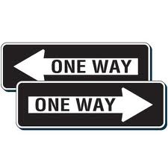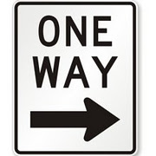

**THERE’S MORE THAN ONE WAY TO**

**“DO THE RIGHT THING”!**

**HALLWAY TRAFFIC CONTROL: IT”S ONLY RIGHT!**

Just imagine this scene: You’re on your way to class and you’re a little late, so you walk a little faster. You start to speed walk through the hallways. You might actually make it before the class begins, but wouldn’t you know it? You hit that traffic jam we all deal with every day.

There are hundreds of students walking down the hallways in every direction. To get through you have to dodge, weave, and press yourself up against the lockers as you try to find an opening. There is more blocking going on than in a Bear’s game!

Or maybe there is a group of people right in front of you, walking as slowly as if they had all the time in the world. They don’t seem to care that the bell is going to ring in 90 seconds. You have two choices: slow down and walk as slowly as they do (and be tardy along with them), or push past them as you give each other annoyed looks.

Kenyon Woods students spend 32 minutes a day walking from class to class in the hallways. And that is not counting the time before and after school. Since we spend so much of our day walking in the halls, it’s a good idea to it make it a pleasant 32 minutes. We can make it a better time for everyone by doing the “right thing”.

Here’s how to “Do the Right Thing” in the halls:

Always walk on the RIGHT SIDE of the hall. If everyone stays to the right, we will all be walking in the same direction. Passing from one place to another will go smoothly and quickly. If someone is walking more slowly than you are, you can easily go around them.

Remember that this is the system driver’s use, too. Imagine how slow we’d have to drive if cars were all over the road! Imagine the car crashes! Staying to the right keeps the roads safe and fast-moving.

It works for hallways, too. STAY TO THE RIGHT! Walking on the right is another way to show respect for yourself, for others and for the environment.

A man was driving the wrong way down a one way street.

A policeman pulled him over.

“Where do you think you are going?” the policeman asked.

“Well”, the man said, “I am not sure. But it must be pretty bad place. Everyone else is leaving!”

Now, go for a walk on the right side. As you walk, look for the one way signs posted on the walls on your right side of the hall. Doing the right thing was never so easy!

***BE POLITE, STAY TO THE RIGHT!***

Developed by Elena Hain