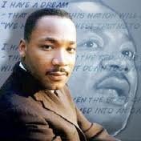The time is always right to do the right
thing. ~Dr. Martin Luther King Jr.~

