**First impressions can be a big factor in whether you get the job you want, or get admitted to the college of your choice. There will be times when you want to make a wonderful impression, and show that you are mature, responsible, and ready for success. Unfortunately, the clothes you might wear when you are out with friends usually aren't suitable for a more important occasion. You need to DRESS FOR SUCCESS in order to show that you are a serious and professional young man or woman. When you want to dress for success, here are examples of what NOT to wear.**

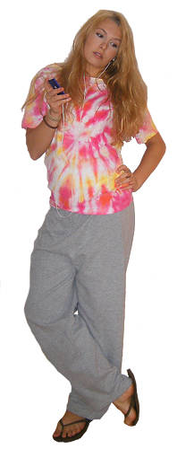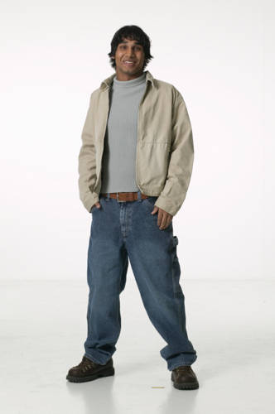

BEFORE AFTER

